AI FAQ Assistant AI - AI-powered FAQ and customer support automation.
Team ID: SWTID-2026-8682
Team Leader: Vinodhini .R & vinodhiniramakrishnan4@gmail.com
Team Member: Yuvanjalin. R& yuvanjalinx08@gmail.com
Team Member: Samundishwari.S & samundishwaris5@gmail.com
Team Member: Sandhiya.G & sandhiyasandhiya59075@gmail.com

Project Overview
- The AI FAQ Assistant is a secure and intelligent backend application developed using Node.js, Express.js, and Mongo DB. The main purpose of this project is to help users create, manage, search, and generate Frequently Asked Questions (FAQs) using Artificial Intelligence.
- The system provides JWT-based authentication to protect private APIs and uses bcrypt to securely encrypt user passwords. Users can create, update, delete, and search FAQ records based on their access permissions.
- The project also integrates Google Gemini AI to automatically generate FAQ questions and answers based on a given topic. MongoDB is used to store user and FAQ information, while Mongoose is used for schema validation and database operations.
- Overall, the AI FAQ Assistant provides a secure, organized, and AI-powered platform for managing FAQ content through RESTful APIs.

Key Objectives:
• Secure User Authentication – Implement JWT-based login and authentication to protect private APIs.
• FAQ Management – Allow users to create, view, update, and delete FAQ records.
• AI-Powered FAQ Generation – Use Google Gemini AI to automatically generate FAQ questions and answers from a given topic.
• Smart FAQ Search – Provide keyword-based search to help users quickly find relevant FAQs.
• Data Security – Protect user passwords using bcrypt hashing and prevent unauthorized access.
• Category Management – Organize FAQs into different categories for easy navigation and management.
• Data Validation – Use Mongoose schemas to validate data before storing it in MongoDB.
• Error Handling – Provide centralized error handling for reliable and consistent API responses.
• RESTful API Development – Build structured and scalable APIs using Node.js and Express.js.

Target Users:
The AI FAQ Assistant is mainly designed for the following users:
- Content Creators – Can create, edit, delete, and organize FAQ content.
- Customer Support Teams – Can quickly search FAQs and use AI-generated answers to handle repeated customer questions.
- Administrators – Can manage users, FAQs, categories, and monitor the overall system.
- Authenticated Users – Can view FAQs, search for information, and use AI-assisted features.
- Public Users / Consumers – Can view published FAQs and search for relevant information without accessing private features.
- Students and Beginner Developers – Can use the project as a practical example of Node.js, Express.js, MongoDB, JWT authentication, and AI integration.

Project Instruction
AI FAQ Assistant is a backend-only project built using Node.js, Express.js, MongoDB, and Mongoose. It provides secure REST APIs for user authentication, FAQ management, FAQ search, and AI-powered FAQ generation using Google Gemini.

Quick Start
npm init
npm install
npm run dev

Steps to Create the Project
- Choose or create a directory for the backend project.
- Open the terminal and navigate to that directory.
- Initialize the Node.js project using:
npm init
- Install the required packages:
npm install express mongoose jsonwebtoken bcrypt cors dotenv @google/genai
- Create the required folders:
  - models
  - routes
  - controllers
  - middleware
  - config

- Configure MongoDB connection and environment variables.
- Implement user registration and login with JWT authentication.
- Create FAQ APIs for creating, viewing, updating, and deleting FAQs.
- Implement FAQ search functionality.
- Integrate Google Gemini AI for automatic FAQ generation.
- Start the development server using:

Pre-requisites

Software | Purpose
Node.js | JavaScript runtime for backend development
MongoDB | NoSQL database for storing users and FAQs
npm | Package manager for installing project dependencies
Express.js | Framework for creating RESTful APIs
Mongoose | ODM for MongoDB schema and database operations
Postman / Thunder Client | API testing and verification
Visual Studio Code | Code editor for project development
Google Gemini API | AI-powered FAQ generation

Main Technologies
- Node.js – Runs the backend application.
- Express.js – Handles API routes and server requests.
- MongoDB – Stores user and FAQ data.
- Mongoose – Defines schemas and validates database data.
- JWT – Provides secure user authentication.
- bcrypt – Hashes user passwords securely.
- Google Gemini AI – Generates FAQ questions and answers.
- Postman / Thunder Client – Tests the REST APIs.

Knowledge Requirements
- JavaScript Basics – Variables, functions, and async programming.
- Node.js & Express.js – Backend development and REST APIs.
- MongoDB & Mongoose – Database and schema management.
- JWT & bcrypt – Authentication and password security.
- API Testing – Postman or Thunder Client.
- AI Integration – Basic knowledge of Google Gemini API.

Project Architecture Image



Technical Architecture
The AI FAQ Assistant follows a layered backend architecture using:
- Client Layer – Postman / Thunder Client sends API requests.
- Express.js Server – Handles HTTP requests and API routes.
- Authentication Middleware – Verifies JWT tokens and user access.
- Controller Layer – Handles application logic and API responses.
- Mongoose Layer – Manages schemas and database operations.
- MongoDB – Stores user and FAQ data.
- Gemini AI Service – Generates AI-powered FAQ content.

Database Architecture
The AI FAQ Assistant uses MongoDB as the primary NoSQL database and Mongoose for schema management and validation.

Main Collections
- User Collection – Stores user name, email, hashed password, and role.
- FAQ Collection – Stores questions, answers, categories, and creator details.
- Category – Organizes FAQs based on different topics.
- AI Generated FAQ – Stores AI-generated question and answer information when required.

Relationships
- User → FAQ: One user can create multiple FAQs.
- Category → FAQ: One category can contain multiple FAQs.
- User → AI FAQ: One user can generate multiple AI-assisted FAQs.
Database Flow:
Node.js → Mongoose → MongoDB → Users / FAQs / Categories

Features:
• JWT Authentication – Provides secure user login and protected API access.
• AI FAQ Generation – Uses Google Gemini AI to generate FAQ questions and answers.
• FAQ CRUD Operations – Allows users to create, view, update, and delete FAQs.
• FAQ Search – Helps users quickly find FAQs using keywords.
• Category Management – Organizes FAQs into different categories.
• Password Security – Protects passwords using bcrypt hashing.
• Data Validation – Mongoose validates data before storing it in MongoDB.
• Error Handling – Provides consistent and reliable API error responses.
• Role-Based Access – Controls features based on user roles and permissions.

Roles and Responsibilities:

Student / Developer:
● Write backend code using Node.js and Express.js
● Create RESTful APIs
● Integrate MongoDB and Gemini AI
● Test APIs using Postman / Thunder Client
● Implement authentication and security
● Push code to GitHub

System (Backend):
● Authenticate users using JWT
● Handle FAQ CRUD operations
● Store and fetch data from MongoDB
● Protect private API routes
● Generate FAQs using Gemini AI
● Validate data using Mongoose
● Handle API errors centrally

PROJECT SETUP AND CONFIGURATION

Creating Project Folder
- Create a new folder with your <project name>.
- Inside that folder, create a new subfolder named src.
- Now open that folder in VS Code


Server Setup (npm init)
Open your root folder terminal in VS Code and run:
Bash

- npm init -y
npm install express mongoose dotenv cors jsonwebtoken bcrypt @google/genai

File and Folder Structure Matrix
Plaintext.

Epic 3: Backend Development

1. Gateway Server Node (src/server.js)
This main entrance mechanism aggregates environment variables, triggers database listeners, and binds network listeners to active environment ports:


- Gateway Express Setup (src/app.js)



3.Security Access Middleware (src/middleware/authMiddleware.js).
Intercepts incoming target queries, extracts transmission header authorization records, and validates token identity context claims:


Epic 4: Database Configuration

Mongoose Schema Definitions

1. Identity Resource Document Schema (src/models/User.js)
Enforces profile field criteria validations and hooks password hashing steps prior to user document persistence:


2. FAQ Resource Document Schema (src/models/FAQ.js)
Models core properties and maps a distinct relational reference link back to the source creator document:


API Router Interface Endpoints

1. Public Authentication Operations (src/routes/authRoutes.js)


2. Protected FAQ Operations (src/routes/faqRoutes.js)


3. AI Automation Operations (src/routes/aiRoutes.js)


Epic 5: Project Executions

Running the API Application
- Install Postman or ThunderClient (VS Code extension).
- Start the backend development server environment parameters:
Bash

- npm run dev

API Testing Specification Demo
To verify operational structural integrity via execution endpoints, map endpoints using the configurations below:

1. Identity Onboarding Path Registration
- Route: POST /api/auth/register
- Access: Public
- Payload Request Body JSON:
JSON

{
"name": "Priya Sharma",
"email": "priya@writeflow.com",
"password": "securepassword123"
}

2. Profile Login Verification Quey
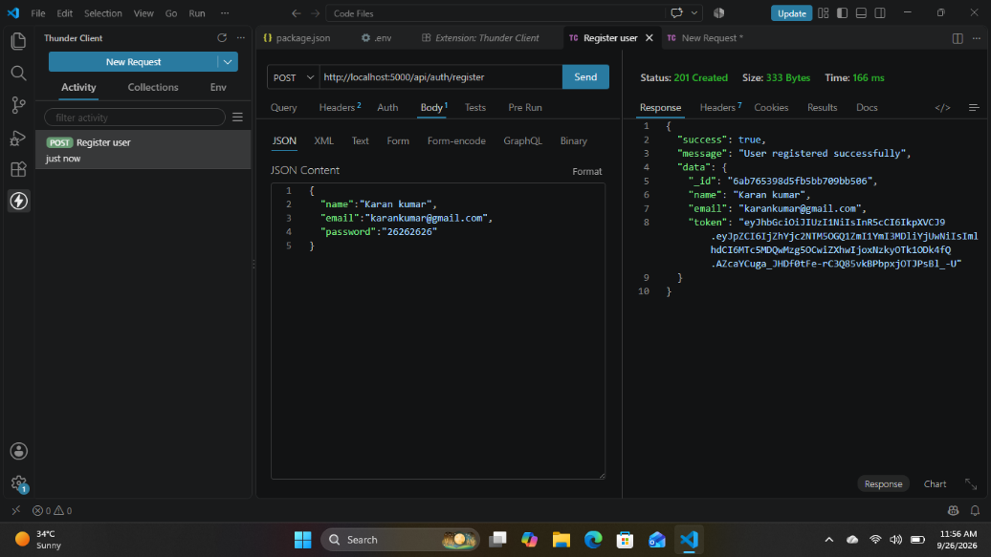
- Route: POST /api/auth/login
- Access: Public
- Payload Request Body JSON:
JSON

{
"email": "priya@writeflow.com",
"password": "securepassword123"
}
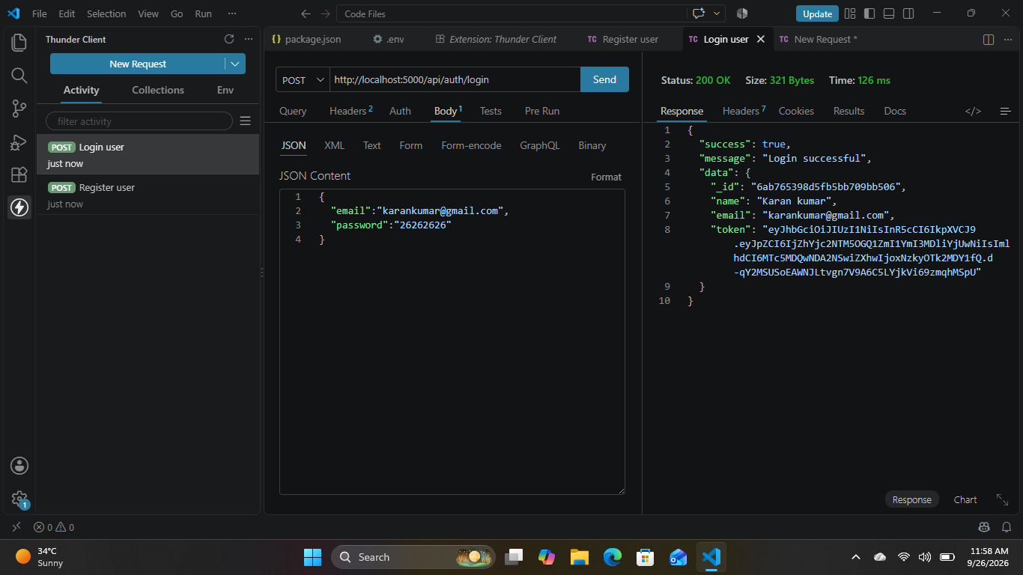

3. Resource Entity Creation (FAQ)
- Route: POST /api/faqs
- Access: Private (Bearer <JWT Token>)
- Payload Request Body JSON:
JSON

{
"question": "How do I configure custom category tags?",
"answer": "Navigate to settings panel, append keyword tags arrays, and save schema.",
"category": "Configuration"
}


. Keyword Resource Entity Fetching (Search)
- Route: GET /api/faqs/search?q=configure
Access: Public
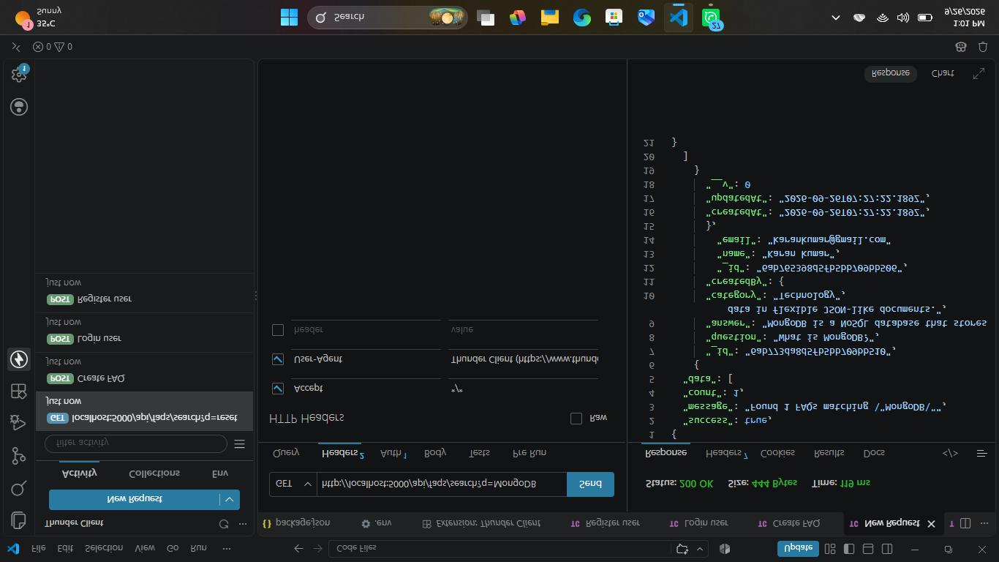

5. AI Intelligent Content Automation (Generate FAQ Pair)
- Route: POST /api/ai/generate-faq
- Access: Private (Bearer <JWT Token>)
- Payload Request Body JSON:
JSON

{
"topic": "Mongoose schema indexing validation runtime workflow optimization"
}

PROJECT DEMO LINK:
https://drive.google.com/file/d/1_do-q65ktlwOmI127wngMy0QGRcSx1Tc/view?usp=sharing
DRIVE LINK:
https://drive.google.com/drive/folders/1vDK2Yh3mlk4uOaLtw9oVZQXckXqdQv6Q?usp=drive_link

